02 DEPARTMENT OF PROFESSIONAL AND FINANCIAL REGULATION

658 MAINE FUEL BOARD

CHAPTER 11 INSTALLATION OF WASTE OIL APPLIANCES AND WASTE OIL SUPPLY TANKS

Summary: This Chapter sets forth requirements for the use of waste (used) oil burning equipment and accessory equipment installations in specific applications.

11.1 License and Experience Required
11.1.1 License Authorities
The installation and service of waste oil appliances is covered as a function granted under the 1 & 2 oils up to 15 GPH and the 1 & 2 oils over 15 GPH oil burner technician license authorities.
11.1.2 Experience
Installation and service of waste oil burning units must be performed by licensed individuals experienced in installing and servicing such equipment.
11.2 General Installation and Service Standards
11.2.1 Nationally-Accredited Testing Laboratory
All heating, chimney and fireplace equipment, as well as any accessory equipment, must be listed and approved by Underwriters’ Laboratories or by an independent nationally recognized testing laboratory. Such listing must be in effect at time of installation.
11.2.2 Workmanship
All work must be conducted, installed and completed in a neat and professional manner reflecting a minimum level of competent workmanship.
11.2.3 Manufacturer’s Instructions
The installation and servicing of waste oil appliances must be made in accordance with the manufacturer’s instructions and State and local codes.
11.2.4 Labeling of Waste Oil Tanks
Waste oil tanks must be labeled with the words “Used Oil” in accordance with 40 C.F.R. § 279.22(c)(1-2).
11.3 Repair or Replacement
Repair of any system or replacement of parts may be made in the same manner as it was in the existing system provided that such repair or replacement is not hazardous. All material, equipment and devices must be constructed and installed in accordance with their specific purposes and listings.
11.4 Maintenance
11.4.1 General
All oil burning equipment and systems, both new and existing, and parts thereof must be maintained in a safe condition.
11.4.2 Notification to Owner of Code Violations
When performing any service on a customer’s heating system, the licensee must notify the property owner in writing of any code violations and make recommendations to address them.
11.4.3 Combustion Efficiency Test Required
When performing an annual tune-up on a heating system, a combustion efficiency test must be conducted and a copy of the test must be posted on-site.
11.5 Installations
11.5.1 Code Compliance Required Prior to Firing
Whenever a furnace, direct-fired hot water heater, or boiler is installed, the total installation must be brought into compliance with the requirements of NFPA 31 and all other rules of the Board BEFORE the furnace, direct-fired hot water heater, or boiler is fired. Prior to leaving the installation (whether installed inside or outside any structure) unattended, the licensed oil burner technician must observe, inspect, and test the equipment to ensure that the installation is operating safely and properly and meets all applicable rules of the Board.
11.5.2 Wiring Compliance Required Prior to Firing
Whenever a new burner is installed, the wiring must be brought into compliance with the requirements of Board’s rules before the unit is fired. The wiring update must include the following:
1. Properly rated fuse or breaker;
2. Properly rated wiring;
3. Properly installed and located emergency switch;
4. Properly installed and located thermal electric switch;
5. Properly installed and located service switch; and
6. Properly installed and located low water cut-off.
11.5.3 Combustion Efficiency Test Required
When performing an installation, a combustion efficiency test must be conducted and a copy of the test results must be posted on-site.
11.5.4 Water Connections to Waste Oil Boilers
11.5.4.1 Hot and Cold Water Piping
A master or journeyman oil burner technician may connect hot and cold water piping from a waste oil boiler to existing piping only in the same room where the installation is taking place. Such connections may not be made beyond any existing branch connection supplying water, in accordance with Title 32, Section 3302.
11.5.4.2 State Plumbing Rules
All piping and safety controls on domestic water heaters, domestic water connections to boilers and water heaters as well as condensate disposal from oil fired condensing appliances must be made in accordance with the currently adopted rules of the Plumbers’ Examining Board as established by Title 5, Section 12004-A, subsection 32 of the Maine Revised Statutes.
11.6 Low Water Control for Used Oil Fired Boilers
11.6.1 Low-Water Control Required
All used oil-fired boilers must be provided with a properly installed and operating low-water cut-off.
11.6.2 Location
The low water cut-off may be installed in, or attached to, the boiler at the level recommended by the boiler manufacturer, but in no case shall the low water cut-off be installed below the crown sheet. The low water cut-off, when not installed directly in the boiler, may be installed either in the main supply line (vertical riser) as close to the boiler as possible, or in a water column of continuous piping attached directly to the boiler.
11.6.3 Appropriate Design
The low water cut-off must be designed and approved for the medium used (steam or water).
11.6.4 No Obstructions
No valves or other obstructive devices shall be installed between the boiler and safety controls or devices.
11.7 Piping, Pumps and Valves
11.7.1 Supply Connections
11.7.1.1 A listed lever or wheel, thermally-operated oil shut-off valve designed to shut off the oil supply in case of fire, must be installed at the burner and at the oil supply tank.
11.7.1.1.1 When outside tanks are used, a thermally operated shut-off valve must be installed where the supply line enters (inside) the building.
11.7.1.1.2 When inside tanks are used and the oil supply tank is installed in a separate room, a thermally operated shut-off valve shall be installed where the line enters the room where the appliance is located.
11.7.1.2 Whenever the oil supply is taken from the top of an oil tank, whether the oil tanks are outside or inside, a thermally operated wheel or lever type shut-off valve must be installed at the tank and at the burner for control of the fuel. A check valve may be used in the supply line, but no valve or obstruction shall be placed in a return line connected to a burner or pump.
11.7.2 Thermally-Operated Valves
Thermally operated valves over ½ inch that are not currently listed may be installed upon receipt of written approval of a Board inspector. The written approval must be requested and received prior to installation.
11.8 Oil Supply and Return Piping
11.8.1 Underground Supply and Return Lines
Whenever a copper oil supply or return line is installed under cement, sub-floors, or earth surface, it must be continuous from the burner to the tank without any splices.
11.8.2 Conduit Required
All copper oil supply and return lines must be encased in a continuous piece of non-metallic liquid-tight conduit such as PVC, ENT, coated copper tubing, or other approved material and must be secured in order to prevent physical damage. The end of the conduit shall not exceed more than two (2) inches from any fitting, except the connection at the fuel tank and at the fuel pump located at the burner shall not exceed 6 inches.
In order to avoid undetected oil leaks under floors, the conduit must be a minimum of one pipe size larger than the oil supply and return lines. The ends of the conduit must penetrate the cement or earth surface a minimum of two (2) inches above grade.
An oil supply or return line that penetrates a foundation wall must be sealed at the wall to prevent the entry of water, insects or rodents.
11.8.3 OSV Valve or PRV Valve Required: Tanks Higher Than Burner
Coated copper tubing must have an OSV valve or PRV valve installed at the tank when used underground.
11.8.4 OSV Valve or PRV Valve Required: Outlets
Wherever an outlet of an oil supply tank is located more than four (4) feet above the burner, an OSV valve or PRV valve is required.
11.8.5 Non-Concealment of Oil Lines
No oil supply or return line shall be concealed in a wall, ceiling, or partition unless access to the oil supply or return line can be had without cutting through existing walls, ceilings or partitions. This may be accomplished by providing removable panels.
11.8.6 Bracket Required
When an oil filter or other accessory equipment is connected to copper piping smaller than ¾ inches and is not located within the vicinity of the oil supply or burner connections, the filter or other devices must be rigidly supported by a wall- or floor-mounted bracket or other means that provides sufficient support and stability for servicing this type of accessory equipment.
11.8.7 Flare Fittings Required
All oil supply and return lines of copper tubing must be connected by flare fittings only. All fittings must be accessible for service or replacement. No compression fittings shall be used on a supply or return oil line unless it is for the introduction of the lines at the top of the tank with a single or double tap bushing.
11.8.8 Flare Frost Fittings Required Outside
All connections of supply or return oil lines located outside shall be made with flare frost fittings.
11.8.9 Disconnected Lines
No oil lines or oil devices which are disconnected from an oil supply tank, burner or unit, shall be left open. Any oil line or oil device which is disconnected or discontinued must be sealed or closed with a plug, cap or other approved fitting.
11.8.10 Removal of Unprotected Supply Lines
Unprotected supply lines that are buried and grouted must be removed from service.
11.8.11 Underground Piping: Tanks Over 660 Gallons
As set forth in the Appendix to Chapter 8 of Board rules, if underground or under-slab piping is connected to a tank of over 660 gallons capacity, or to tanks with an aggregate capacity of over 1320 gallons, the installation of the underground piping must be installed by a certified underground oil tank installer and otherwise meet Maine Department of Environmental Protection requirements.
11.8.12 Reporting of Oil Spills Required
Oil spills, regardless of the amount spilled, must be reported within two (2) hours to the Maine Department of Environmental Protection in accordance with the Appendix to Chapter 8 of Board rules.
11.9 Electrical Equipment, Required Control Switches
11.9.1 Thermal Cut-Off Switch
A thermal cut-off switch must be wired into the burner circuit to shut off the burner in the event of a fire at the unit. The switch must be placed at the highest point directly above the unit to be fired with the thermal element pointed downwards and must be placed on the bottom of the floor joist or stringer at the front of the unit. In no case shall it be lower than the point where the flue connector enters the chimney. The switch must be wired to shut off the burner, circulating fan, forced or induced draft fan and any remote oil pump that is not an integral part of the burner. A thermal electric switch is required for each oil-fired unit in a multi-appliance installation.
11.9.1.1 On multi-unit installations, the emergency and thermal electrical switches must be wired in series through individual unit relays so that, if one switch is opened, all equipment will be rendered inoperable whenever the "EMERGENCY" switch is opened.
11.9.1.2 All remote pump sets must have a thermal cut-out switch installed as follows:
1. Maximum of three (3) feet above pump set;
2. The element must be pointed downwards; and
3. The switch must be supported in accordance with NFPA 70.
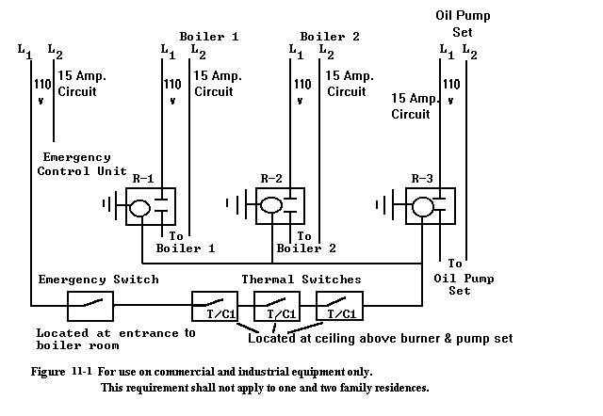
11.9.2 Service Switch
A service disconnect switch for control of the burner while observing the flame must be placed at the unit within arm’s reach of the technician.
11.9.3 Emergency Switch
11.9.3.1 If the entrance to the boiler room is only accessible from the outside, the emergency switch may be placed at the inside not more than one foot beyond the door opening. An emergency switch shall not be placed outside of any building.
11.9.3.2 On commercial and industrial equipment, the emergency switch must be installed in accordance with Figure 11-1 on multi-unit installations. The requirements of Section 11.9.1.1 do not apply to one- or two-family residences.
11.9.3.3 On multi-unit installations, the emergency shut-off switch must be placed at the outside entrance of the room containing the appliances. The emergency switches and the thermal cut-off switches must be wired in series through individual unit relays so that, if the emergency switch is opened, all heating equipment in the room and the remote pump set will be rendered inoperable. This application also applies if there are two or more appliance rooms in the same building that are connected to a common fuel supply system.
11.9.4 Controls Containing Mercury
Thermostats containing mercury must be disposed of in accordance with all federal and state regulations. (Refer to 38 M.R.S. § 1663 and check with your local supplier.)
11.10 Safety and Pressure Relief Valves
11.10.1 Approved Safety or Pressure Relief Valve Required
Steam and hot water boilers must be equipped with listed or approved steam safety or pressure relief valves that conform to ASME requirements. A shut-off valve shall not be placed between the relief valve and the boiler or on discharge pipes between such valves and the atmosphere.
11.10.2 Termination
11.10.2.1 All steam safety or pressure relief valves must terminate in a manner which precludes the possibility of accidental scalding in accordance with ASME.
      - Steam safety relief valves over two (2) inches in diameter must terminate outside of the structure in a safe location.
      - Steam safety or pressure relief valves which terminate in the structure must terminate six (6) inches to twelve (12) inches above the floor.
11.10.3 Installation in Upright Vertical Position Required
Steam safety and pressure relief valves on boilers must be installed with the spindle in the upright vertical position.
11.11 Water and Steam Boiler Pipe Supports
11.11.1 General
Piping must be supported with pipe hooks, metal pipe straps, bands, brackets, or hangers suitable for the size of the piping and must be of adequate strength and quality and located at intervals so as to prevent or damp out excessive vibration.
11.11.2 Spacing
Spacing of supports shall not be greater than shown in Table 11-1.
11.11.3 Allowance for Expansion and Contraction
Supports, hangers, and anchors must be installed so as to not interfere with the free expansion and contraction of the piping between anchors. All parts of the supporting equipment must be designed and installed so that they will not be disengaged by movement of the supporting piping.
Table 11-1
Support of Piping

Steel Pipe, Nominal Size of Pipe  (Inches) | Spacing of Supports  (Feet) |  | Nominal Size of Tubing  (Inch O.D.) | Spacing of Supports  (Feet)
1/2 | 6 |  | 1/2 | 4
3/4 or 1 | 8 |  | 5/8 or 3/4 | 6
1 1/4 or larger (horizontal) | 10 |  | 7/8 or 1 | 8
1 1/4 or larger (vertical) | every floor level

11.12 PEX Tubing
All PEX tubing and fittings used in heating systems must be listed by the manufacturer for use on heating systems and be manufactured with an oxygen barrier.
11.13 Emergency Temporary Repair of Warm Air Heat Exchangers
Emergency temporary repairs of warm air heat exchangers in waste oil burning appliances are allowed if the safety limitations of the repairs are explained in writing to the owner at the time of the repair.
11.14 Welding of Non-Residential Warm Air Heat Exchangers
11.14.1 General
11.14.1 Welding of non-residential warm air heat exchangers is permissible only as set forth in this Section (11.14).
11.14.2 Welding of residential warm air heat exchangers is not permissible under any circumstances.
11.14.2 Consultation With Manufacturer Required
The manufacturer must be consulted to determine whether the welding of a heat exchanger is sound engineering practice. The manufacturer must provide a written statement as to the feasibility of its heat exchanger being welded. If the heat exchanger is no longer in production, a master licensee must make a written request to the Board and obtain written approval from the Board before the repair is undertaken.
11.14.3 Master Licensee to Oversee Welding Repair
The repair of a heat exchanger by welding must be performed by a welder in a procedure suitable for the material. A master licensee must oversee such repairs. The master licensee must receive guidance from the welder as to the feasibility and acceptability of performing the welding procedure of the metals prior to the repair of any heat exchanger. After completion of said repairs or welding, the master licensee must obtain a written statement from the welder documenting that the heat exchanger has been welded, tested and is acceptable for use without leakage of after-products.
11.14.4 Documentation of Repair to be Provided to Owner
Written documentation of said repairs or welding must be provided to the owner. The original documentation must be kept on file by the master licensee who requested the welding. A copy of all the repair documents containing, at a minimum, the following information must be sent to the Board:
1. The name of the owner and location where the repairs were completed;
2. The name and address of the welder;
3. Specific area(s) or location(s) where the repair(s) or welding was performed;
4. Written approval of the repair from the manufacturer where applicable;
5. Equipment identification information, i.e., name, model number, serial number and gross Btu rating; and
6. The name, address, and license number of the master licensee who requested the repair.
11.14.5 Limitation
Welding repair of a heat exchanger may be performed only once. A subsequent welding repair may not be made to a heat exchanger unless a master licensee makes written request to the Board and obtains written approval from the Board before the repair is undertaken.
11.15 Type of Fuel
11.15.1 Permissible Fuels
Waste oil fuel tank(s) may contain: 1 and 2 fuel oils; crankcase oil up to 50 SAE; automatic transmission fluid; and hydraulic oils; and specified refined waste fuels only.
11.15.2 Prohibited Fuels
Other types of liquids such as anti-freeze, cleaners, thinners, solvents, gasoline or additives, and any other types of hazardous materials shall not be introduced into a waste oil supply tank.
11.16 Used Underground Oil Tanks
Abandoned underground oil storage tanks shall not be used for aboveground storage of oil unless such use has been approved by:
1. The Maine State Fire Marshal; or
2. A Maine licensed professional engineer, or other person meeting the requirements of the statutes and rules governing professional engineers practicing in Maine, certifies that the tank meets all applicable specifications and requirements of NFPA 31.
11.17 Oil Supply Tank Arrangement
11.17.1 Code Compliance Required
Except as set forth in Section 11.17.2, all tanks serving a waste oil appliance must conform to NFPA 31 and this Chapter.
11.17.2 Exception
A waste oil supply tank of 660 gallons, or two tanks of aggregate capacity, supplying a Waste Oil Appliance must be installed with a receptacle or funnel used specifically for introducing waste oils into a specifically marked waste oil supply tank when the tank and accessories have a 2-inch diameter (nominal inside diameter) iron pipe vent to the outside of the building or structure.
11.17.3 Arrangement of Waste Oil Tank Recovery Receptacle
The arrangement of the waste oil tank recovery receptacle must comply with the following:
11.17.3.1 The recovered waste oil must be introduced into the supply tank manually through a valved recovery pan or funnel for waste oils only and must be located at the top of the tank. See Figure 11-2. The receptacle to receive the oils may be installed as follows:
1. Install a close x 2-inch threaded (NPT) metal nipple in the oil supply tank’s 2-inch access opening;
2. Install the receptacle (funnel, pan, catch basin, etc.) at the top of the valve; and
3. Install a gauge in the other available access opening of the tank.
11.17.3.2 Spillage by individuals pouring recovered waste oil from a pan, catch basin, or other type of recovery container, must be minimized by metal steps, corresponding to the height of the tank, so that an individual does not have to reach beyond his or her shoulder level while transferring the fuel from the recovery container to the oil supply receptacle. Steps provided must be a minimum of three feet (3) wide, with a tread height of not more than eight (8) inches. Ladders are not an acceptable alternative.
11.17.3.3 Any spillage must be cleaned up immediately and reported to the Maine Department of Environmental Protection.
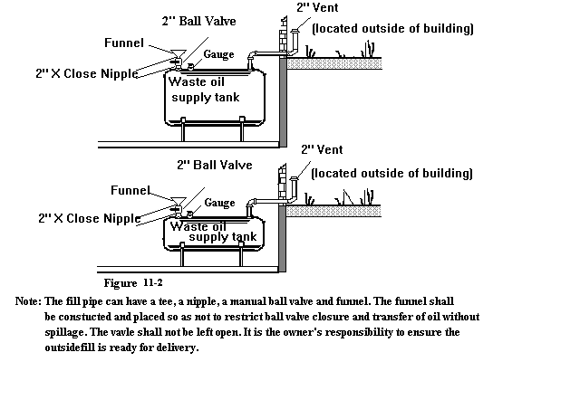
11.17.4 Optional Tank Arrangement
As an option to the tank arrangement in Section 11.17.3 and Figure 11-2, the tank arrangement may be supplied with a funnel and a fill and vent pipe extending to the outside, provided that the fill point is identified by a metal placard attached to the building stating: “Waste oil tank, check for inside valve closure prior to filling.” See Figure 11-3.
11.18.4.1 The waste oil supply tank in Figure 11-3 must be provided with a combination oil gauge and vent alarm at the vent pipe due to the availability of only three (3) access openings in the tank. Waste oil tanks with four (4) access openings may use a separate gauge and vent alarm.
11.18.4.2 Spillage due to pouring recovered waste oil from a pan, catch basin, or other type of recovery container must be minimized by metal steps, corresponding to the height of the tank, so that an individual does not have to reach beyond his or her shoulder level while transferring the fuel from the recovery container to the oil supply receptacle. Steps provided must be a minimum of three (3) feet wide, with a tread height of not more than eight (8) inches. Ladders are not an acceptable alternative.
11.18.4.3 Any spillage must be cleaned up immediately and reported to the Maine Department of Environmental Protection.
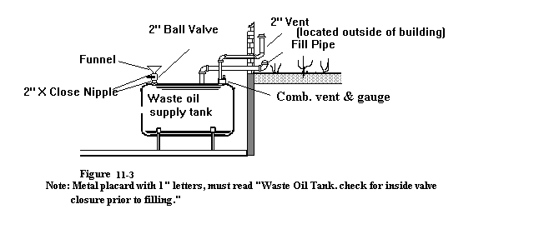

STATUTORY Authority: 32 M.R.S. § 18123(2)

Effective Date:

September 27, 2014 – filing 2014-244

REPEALED AND REPLACED:

September 16, 2023 – filing 2023-167

